
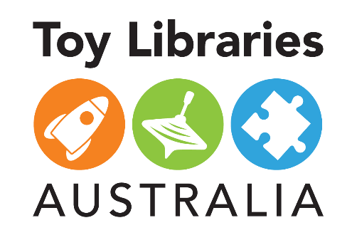
Toy cleaning instructions

As part of Toy Libraries Australia’s Covid-safe plan approved by public health officials, all members are required to thoroughly clean their toys prior to returning them to the toy library. If you do not clean your toys at home, you will be requested to clean them in the toy library.

How to clean
Wipe the toy thoroughly with a cloth damp with either a pH neutral detergent (such as diluted dishwashing detergent) or a 2-in-1 cleaner/disinfectant (most multipurpose sprays available at the supermarket). If using a 2-in-1 multipurpose spray, the solution must be sprayed onto the cloth until it is quite damp. You can use something like an old toothbrush or a cotton bud to get into hard to reach places.
Dry the toy with a tea towel or leave to dry overnight. Please make sure the toy is perfectly dry before returning it to its bag or box. Do not submerge toys in water as they can trap water inside them or in the case of wooden toys, they can get too wet to effectively dry.

Special tips
- Baby Rattles – Do not to immerse rattles in water as they collect water which can lead to harmful bacteria developing. Wipe the surface with a cloth.
- Wooden Toys and Train Sets – Wipe over. Allow time to thoroughly dry. These toys should not be immersed or soaked.
- Duplo/Lego – Wash well with hot soapy water and a toothbrush. Rinse and leave to drain overnight.
- Bath toys – Please wash after using in the bath and ensure no water remains trapped in the toy.
- Outdoor/Sandpit Toys – These must be cleaned well remembering that the next member may wish to use it inside. Remove all sand and dirt and clean well with hot soapy water.
- Board Games and Cardboard Puzzles – Paper-based materials, such as puzzles and games, are not considered a high risk for transmission and do not need additional cleaning or disinfection procedures. Please clean counters and other plastic parts of a game.
- Fabric items (Dress-ups/Puppets/Dolls Bedding/Infant Soft Toys) – Hand wash or gentle machine wash with laundry detergent and hang to thoroughly line dry.
- Bikes, scooters and other ride-ons – These must be washed, keeping in mind that the next member may wish to use them inside.
- Toy storage bags and boxes – Wipe handles and all areas that have been touched, ensuring everything is dry before placing toys back in them.
If anyone in your family has been unwell (e.g. vomiting, diarrhoea, respiratory infection) please contact the toy library prior to returning the toy for further advice.

